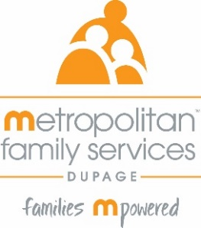
In-Person 40-hour Domestic Violence Training
November 12th – November 21st
Time: Monday-Thursday 9a-4pm or 9a-5pm
In-Person

Training Schedule:

Tuesday, November 12th 9:00-12:00pm Foundations of DV
1:00-4:00pm Dynamics of DV Part 1

Wednesday, November 13th 9:00-12:00pm Dynamics of DV Part 2
1:00-4:00pm Effects of DV on Children

Thursday, November 14th 9:00-12:00pm Cultural Humility
1:00-4:00pm TDV & Post Separation Abuse

Monday, November 18th 9:00-12:00pm Underserved Populations Part 1
1:00-4:00pm Underserved Populations Part 2

Tuesday, November 19th 9:00-12:30pm Services for Survivors Part 1
1:30-5:00pm Services for Survivors Part 2 &
People Who Cause Harm in Relationships

Wednesday, November 20th 9:00-12:00pm Safety & Assessment
1:00-4:00pm IDVA & Legal Issues

Thursday, November 21st 9:00am-12pm Professional Conduct

Registration link: https://www.eventbrite.com/e/40-hour-in-person-dv-training-november-2024-tickets-1004711598437

Registration open: August 28th at 9am
Registration ends: November 7th at 9am

